
Amazon Interview Worksheet
FRUGALITY
Definition and Indicators
Frugality: Accomplish more with less. Constraints breed resourcefulness, self-sufficiency and invention. There are no extra points for growing headcount, budget size or fixed expense.
What this looks like in Practice
As a people manager do you… | As an individual contributor do you…
- Ask, “Does this spend make a positive impact for the customer?
- Role model behaviors for team by not exhibiting “hierarchical” behavior like taking a larger office, expensing lunches, being extravagant?  - Being transparent with team about costs – creating a general awareness that things cost money?  - Understand the difference between frugal and cheap? | - Creatively spend money and share your resources?  - Seek out “no-cost” alternatives prior to spending?

Frugality - Suggested Behavioral Interview Questions
For each question you choose, use a separate STAR Worksheet
Questions for (Manager) in parentheses

- Give me an example of how you have helped save costs or eliminate waste within your operation.
- Tell me about a time when you had to make tradeoffs between quality and cost. How did you weigh the options? What was the result?
- Tell me about a time you had to get something done with half or two thirds of the resources you thought you’d need for the project or initiative.
- Tell me about a time when you generated a creative solution to a problem or project without requiring additional resources. What was the problem? What was the solution and how did you come up with it?
- Tell me about a time you didn’t have enough resources to do something you felt was important but found a creative way to get it done anyway. What drove you to seek out creative solutions?
- Give an example of a time you requested additional funding/budget to complete a project. Why was it needed? Did you try to figure out another approach? Did you get the additional resources? Why or why not?
- Give an example of a time when you challenged your team to come up with more efficient solution or process. What drove the request? How did you help? (Manager)
- How do you determine when to award or ask for additional resources? What criteria do you use for making the call? (Manager)
- Tell me how you have created organization (or customer) value through either increased revenue stream or lowering the cost structure. (Manager)

STAR WORKSHEET
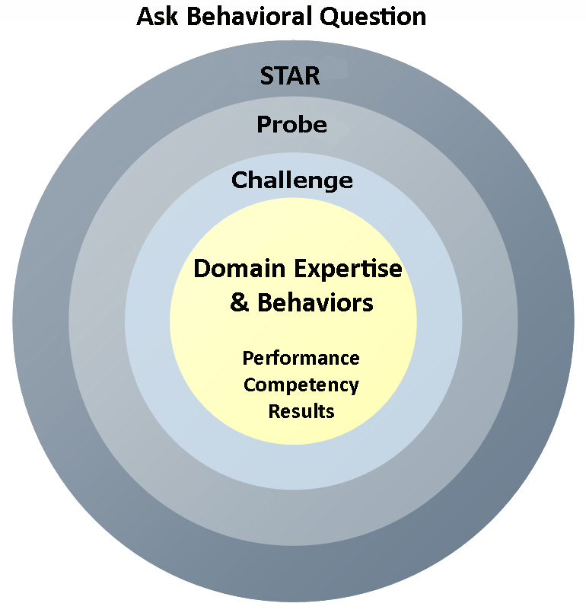
Your Behavioral Question:___________________________________________________________________Leadership Principle:_________________

- Choose behavioral question that provoke specific examples or stories for your assigned Leadership Principle(s).
- Process the example using STAR. Stories have beginnings (Situation/Task), middles (Actions) and ends (Results).
- Once you have established the story, PROBE to dive deeper on your assigned competency (Leadership Principle), get clarity or pursue a concern.
- If appropriate, CHALLENGE the candidate’s statements, decisions or thought process.
S  T | SITUATION/TASK - Describe the situation/task you faced and the context of the story  Answers the questions: where did this occur, when did it happen, why is it important?  Probing Questions:  - Why is this important? What was the goal?  - What was the initial scope of the project? What were the challenges?  - What were the risks and potential consequences if nothing happened?  Challenge Questions:  - Why did you choose this story to illustrate a xyz accomplishment?  - What other stories can you think of that demonstrate.. xyz?  - Could you come up with an example that is more recent? | Notes
A | ACTION - What actions did you take?  Answers the questions: what did you personally own, how did you do it, who else was involved?  Probing Questions:  - Deep probe functional expertise and/or assigned core competency.  - Were you the key driver or project owner?  - What was your biggest contribution? What unique value did you bring?  - What were the most significant obstacles you faced? How did you overcome them?  Challenge Questions:  - What did you do specifically versus the team?  - How did you set priorities…deal with xyz problem… or get manager buy-in?  - What decisions did you challenge? Why? How did you influence the right outcome?
R | RESULTS - How did you measure success for this project? What results did you achieve?  $ Cost savings, revenue generation  # Quantify to understand volume, size, scale  % Percentage change, year over year improvements  Time to market, implementation time, time savings  Impact on the customer, the team  δ Quality improvements  Probing Questions:  - Why did you choose to focus on these results? What other results were important?  - You mentioned revenue, what percentage change is that year over year?  - What trade-offs did you have to make to achieve this? (quality, cost, time)  - I’m concerned about… (the time it took, the volume, the customer impact), tell me more…  Challenge Questions:  - What were the lessons learned? What would you have done differently?  - How would you implement this at Amazon?  - How did these results compare to your actual goals? (refer back to goal stated in Situation)

